UPDATED LETTER – PLEASE NOTE THE AMENDED DATE
10 November 2017

Dear Parents/Carers

Achievement Celebration: 17 November 2017

We will be holding a celebration and presenting copy certificates to those students who achieved qualifications during 2016-2017 on Friday, 17 November 2017 at 1.30pm.

Your child will be receiving a certificate(s) and you are invited to attend. Please complete and return the reply slip below if you will be attending.

There will be refreshments available beforehand from 1.00-1.30pm and you are welcome to take your child home with you at 2.30pm. If you decide to do this, please leave the school premises promptly to avoid the traffic and ensure that you advise transport that they do not need to collect your child.

Yours sincerely

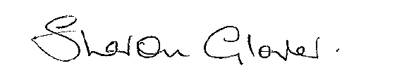

Sharon Glover
PA to Headteacher

……………………………………………………………………………………………………………..

REPLY SLIP: Return to Sharon Glover

Celebration: 17 November 2017

Student:………………………………………………………………. Class: …………………………

I/We will be attending the celebration and require ……………. seats (insert number required)

Name: ………………………………………………………………..

