15 November 2017

Dear Parents/Carers

On Thursday 14 December 2017 we will be having our school Christmas lunch and, in order to assist the catering team, we need to know if your child/children will be having a lunch on that day.

The cost will be the usual £2.30 and payment should be made in the normal way.

Please return the reply slip below, indicating whether or not your child/children will want a school Christmas lunch and whether or not they want a vegetarian option, by Wednesday 22 November 2017.

Yours sincerely

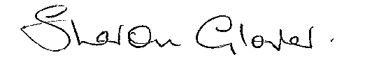
Sharon Glover
PA to Headteacher

……………………………………………………………………………………………………..

REPLY SLIP

To: Sharon Glover

My child/children will be / will not be having a school Christmas lunch on Thursday 14 December.

Please choose
Nam | Clas | Turkey / Vegetarian
Nam | Clas | Turkey / Vegetarian

Signed: ____________________________________________ Date: ________________

Print Name: ____________________________________________________

