19 December 2017

Dear Parents / Carers

Carroll Class staff changes

I am pleased to advise that we have appointed a new teacher to join our MGS team – Mrs Victoria Tofts.

Mrs Tofts is an experienced special needs’ teacher and we are very excited to have her join us. She will be taking up her post as soon as her references and DBS clearance have been received, which we hope will be early January 2018, and she will take over from Ms Kincses as Carroll’s class teacher.

Ms Kincses remains in post as Head of the Towards Independence Clusters.

A “Meet the Team” session will be arranged for mid-January so that you can meet Mrs Tofts.

Yours sincerely
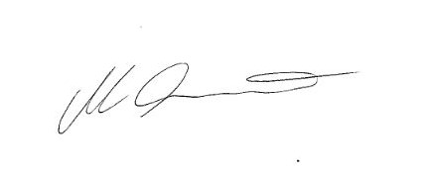
Joolz Scarlett
Headteacher

