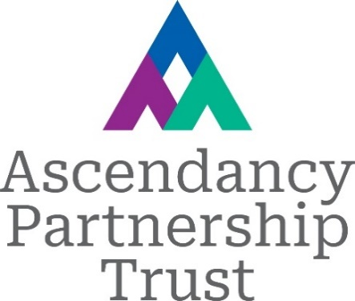

Member/Trustee Skills Questionnaire
This questionnaire forms part of the selection process. Please answer the questions instinctively and honestly. There is no expectation there will be high scores in all areas and a 0 score is not a bar to appointment.
Name:
Position applied for:

Please give your assessment of your knowledge, competence and experience against each statement, by entering a score of 1 to 5, where:
- 1 is no knowledge or experience;
- 2 is limited knowledge or experience but further training/support required;
- 3 is adequately competent but further support/training desirable;
- 4 is very competent with further training/support not required and
- 5 is expert, able to advise others.
Rather than asking you to give evidence and examples for each skill, we have provided a box at the end of the skills section for you to supply relevant evidence and examples to explain your scores.
Experience could come from employment, voluntary work, governorship – please give as much detail as you can as this helps to give more background to the numerical ratings.
Score 1-5
Understanding of education
Assimilating information – the ability to understand written and verbal information received, and identify key points
Analysis and drawing conclusions – the ability to assess and choose between options, and to draw appropriate conclusions
Communication – the ability to express yourself clearly and unambiguously, and to listen to and understand others
Confidence – to state your view, ask the naïve question and have courageous conversations about challenging issues
Questioning - the ability to ask searching questions in a non-confrontational way
Assertiveness – the ability to make a point, or stand your ground, without being abrasive or damaging relationships with others
Influencing – the ability to get other people to consider your perspective, while taking their views and opinions into account
Negotiation and agreement – the ability to navigate differences of opinion and identify common ground and points of agreement or consensus
The ability to manage conflicts of interest and maintain confidentiality
Experience of governance (in education or other sectors, charity, business etc)
Experience / skills in maintaining a strategic focus, setting the vision and strategic objectives.
Experience / skills in self-evaluation and/or impact assessment
Experience / skills in data analysis
Experience / skills in performance management, setting targets, monitoring and evaluation
Experience / skills in risk assessment
Experience / skills in financial monitoring, understanding of accounts
Experience / skills in chairing, team leadership
Experience / understanding of the perspectives of stakeholders, e.g. students, parents, partners
Experience / understanding of safeguarding, child safety
Experience / skills in premises and facilities management
Experience / skills in human resources / personnel
Experience / skills in legal matters
Experience / skills in public relations, branding & marketing
Experience / skills in health and safety
Experience / skills in project management
Experience / skills in ICT and management information systems
Experience of handling complaints, grievances or appeals
Knowledge of secondary education, locally or nationally
Knowledge of nursery and/or primary education, locally or nationally
Knowledge of further and higher education, locally or nationally
Knowledge of special educational needs, including health and disability
Knowledge of other children’s and young people’s services (please specify)
Knowledge of the local and/or regional economy, employers, careers
Other relevant specialist knowledge – please describe:

Evidence and Examples for high scoring skills in the responses above:

Please indicate if you have any potential conflicts of interest:

Anything else you would like to tell the Trustees:

I have an enhanced DBS certificate registered with the DBS Update Service: YES/NO

Signed: Date:

Thank you for taking the time to complete this questionnaire.

